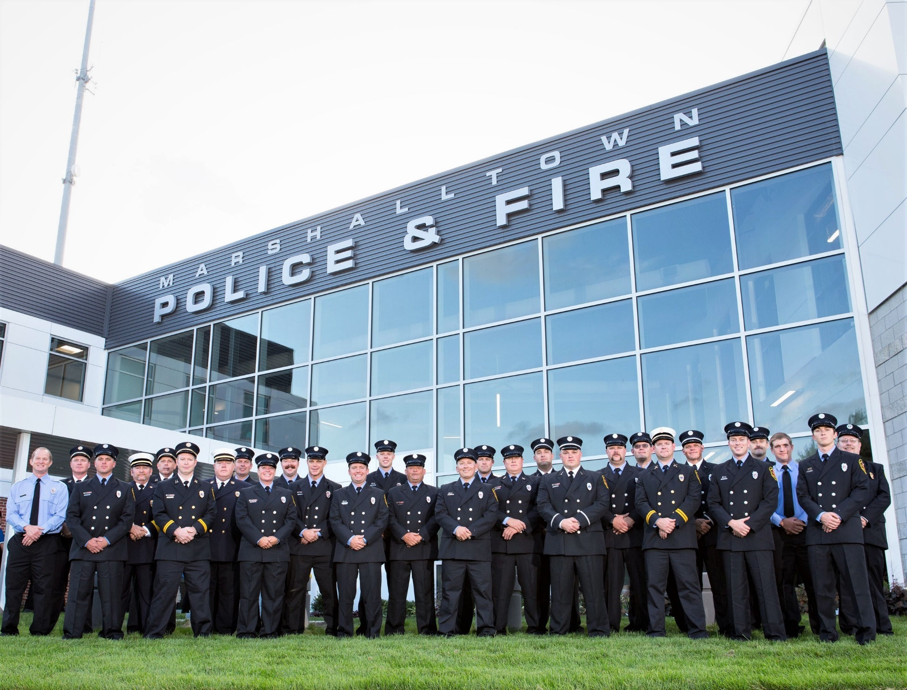
Marshalltown Fire Department
Annual Report 2019

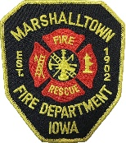
________________________________________________________________________________________________

Message from the Chief
The members of the Marshalltown Fire Department are pleased to offer you this annual report for the year 2019. This is a working document that addresses your fire departments daily activities and accomplishments. It is our goal to offer the highest level of service possible for the citizens and to the business community of Marshalltown.
On August 28, 2019, the City, Fire Department, and Police Department opened a new joint facility. The state-of-the-art facility will serve both departments well for many years. Additionally, the joint training room will allow both departments the ability to host regional and state training classes. This presents an opportunity for businesses in Marshalltown to provide hotel rooms and meals to those attending training.
Also in 2019, department training hours increased by 17% (EMS and Special Recue) and hours spent on incidents increased 9.7%. From a call standpoint, Marshalltown Fire Department experienced a 1.6% decrease in calls for service (2,705 vs. 2,749).
Finally, 2019 marked my fifth year of service to the community as Fire Chief. I am proud of the accomplishments and improvements made during this time and look forward to what the next five years will bring. I am blessed to be able to serve in this capacity and lead such a dedicated organization.

Sincerely,
David Rierson
David Rierson - Fire Chief

Organizational Structure

Mayor & Council
Josh Warnell
Fire Marshal
Jessica Kinser
City Administrator
FF Jeremy Weiermann
FF Alex Needham
FF Cody German
FF Keri Larsen
FF Patrick Cornwell
FF Curtis Raue
FF Christian Case
FF Tyler Homeyer
FF Jacob Moore
FF Dan Oswald
FF Greg Pepper
FF Brad Wilson
FF Cody Schmidt
FF Rodney Burgess
FF Jason Johnston
FF Grant Wall
FF Marc Grant
FF Matt Gorder
Curtis Cecak
Lieutenant
Nathan White
Lieutenant
Nick Hanus
Lieutenant
Don Barker
Captain
Tim Hillygus
Captain
Scott Doe
Captain
David Shearer
Chaplin
Karen Allen
Administrative
Assistant
Christopher Cross
Deputy Chief
David Rierson
Fire Chief
Administrative Staff & Officers

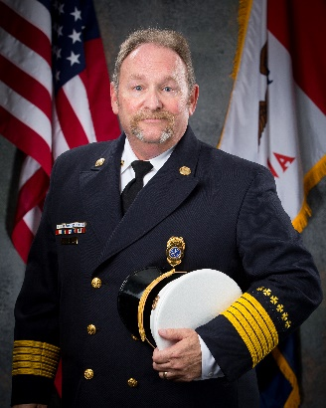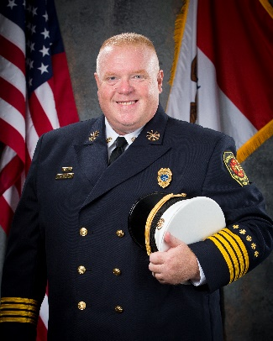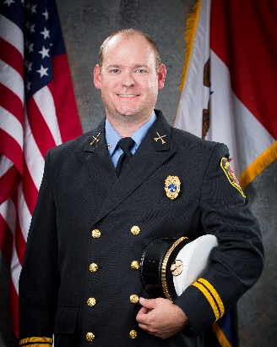
Joshua Warnell – Fire Marshal
Christopher Cross – Deputy Chief
David Rierson – Fire Chief
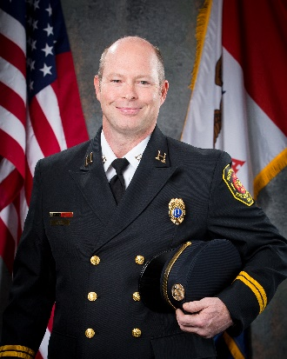
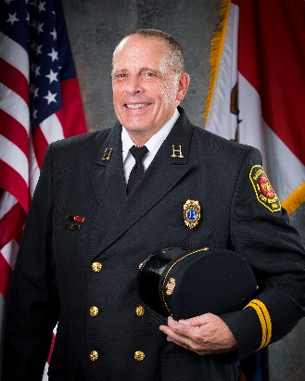
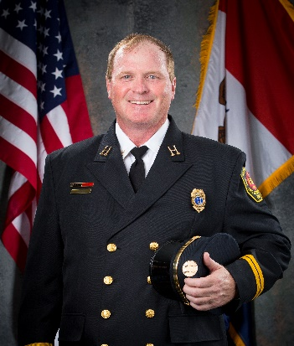

Don Barker - Captain
Tim Hillygus - Captain
Scott Doe - Captain
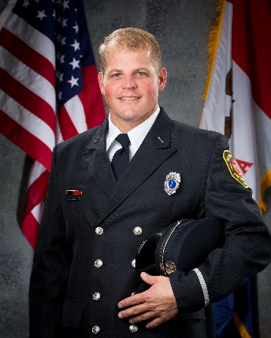
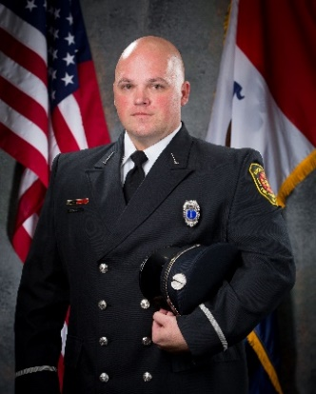
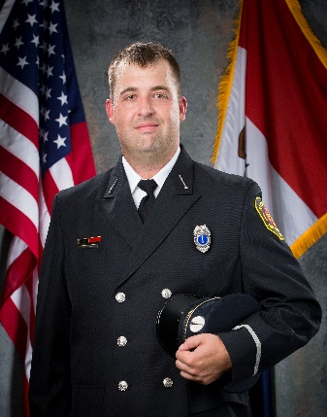

Curtis Cecak - Lieutenant
Nick Hanus - Lieutenant
Nathan White - Lieutenant
Reports and Statistics
Incident Breakdown
As an all-hazards department, Marshalltown Fire Department responds to emergencies that include fires, emergency medical calls, hazardous materials incidents, water and ice rescue, trench and confined space rescue, and vehicle extrication. In 2019, the department responded to 2,705 requests for service, which represents a decrease of 1.6 percent over 2018 (2,749). Listed below are explanations of the categories and a chart breaking down fires by type and other calls for service as well as a map showing distribution of calls throughout the City.

- EMS: Includes emergency medical calls and extrications.
- Hazardous Condition-No Fire: Includes hazardous materials spills, arching or shorted electrical equipment, and electrical wiring issues.
- Fires: Includes structural, vehicle, brush and weeds, and rubbish.
- False Alarm: Includes accidental alarm trips.
- Service Calls: Includes Smoke or odor scares, animal rescues, water problems, and public assistance.
- Hazardous Materials: Includes release, containment, and mitigation of a hazardous substance.

Distribution of Calls
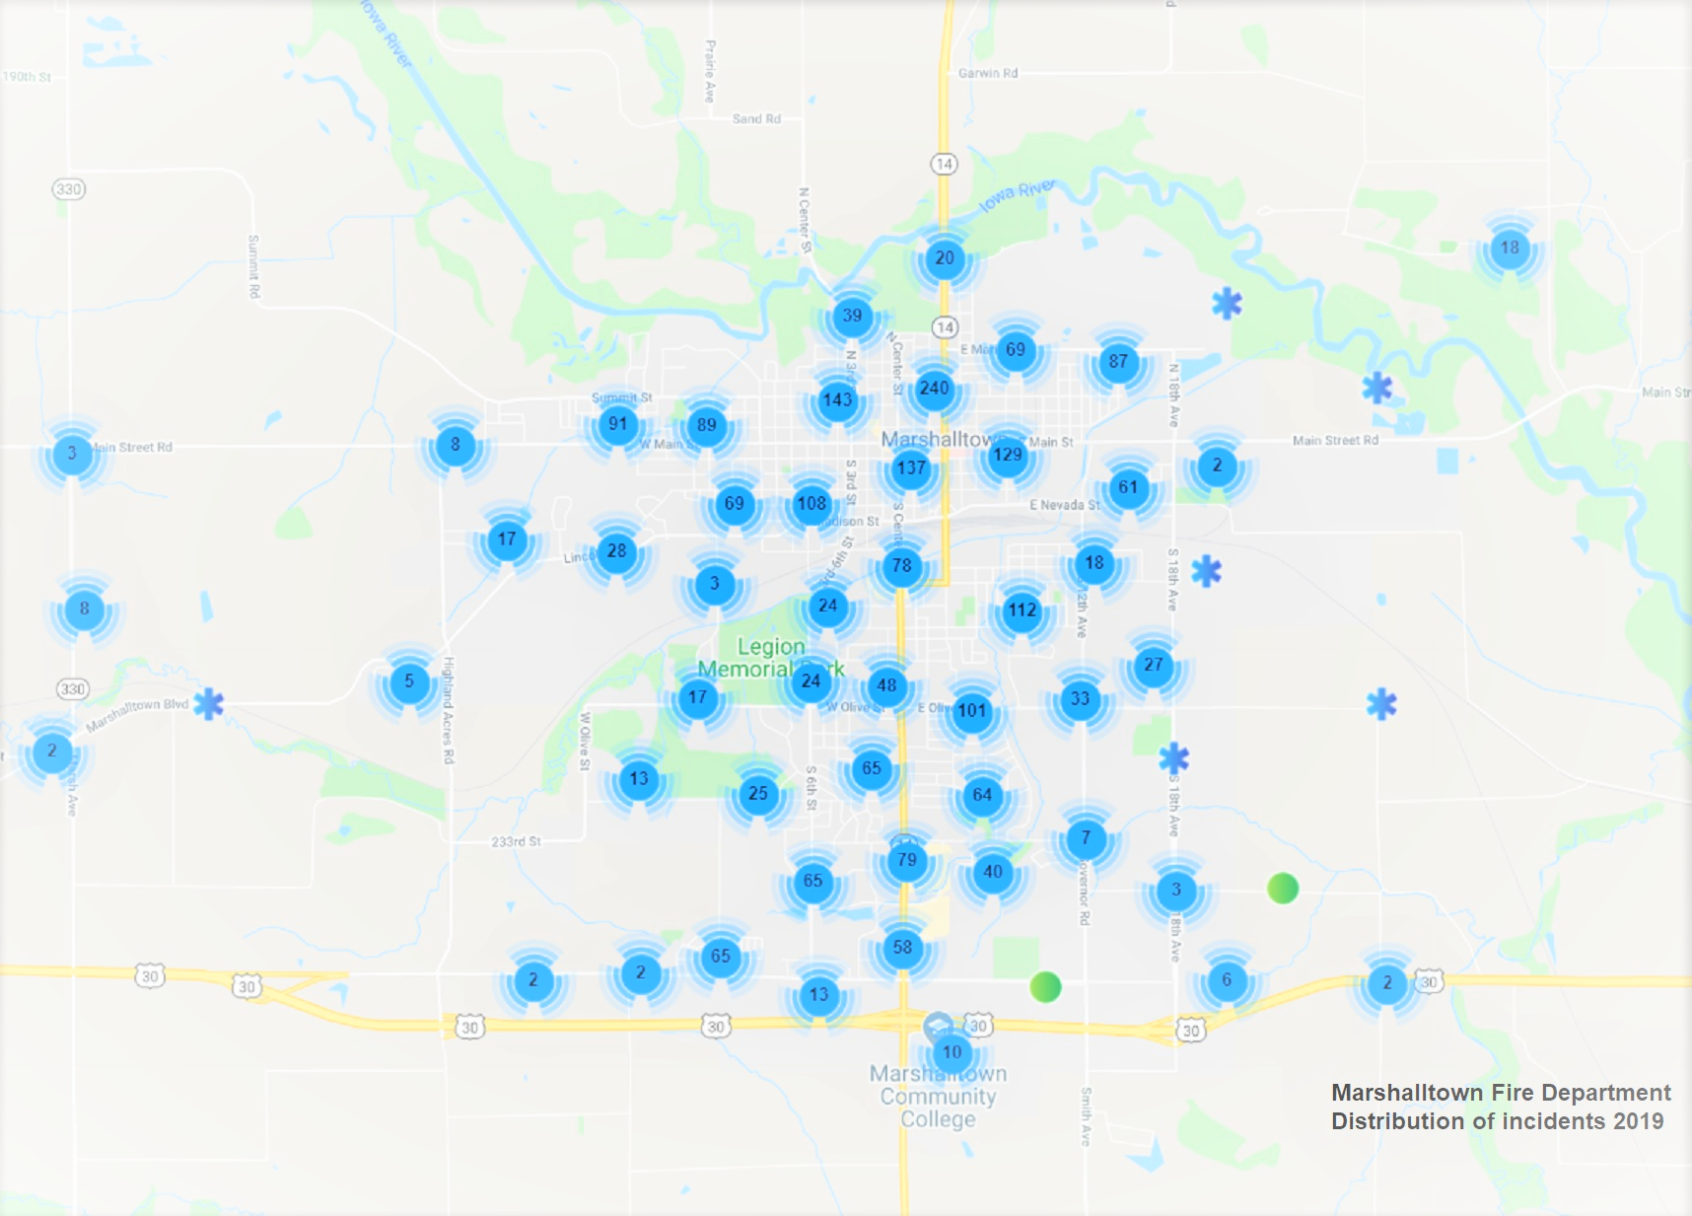
 | Number of Incidents
Private Dwellings (1 or 2 family) | 25
Apartments (3 or more families) | 12
Public Assembly | 3
Other Residential | 2
Industry & Manufacturing | 1
Stores & Offices | 6
Barns, Storage, Garages | 2
Outbuildings | 1
Total Structure Fires | 52
Vehicle Fires | 15
Brush/Weeds | 5
Dumpsters/Rubbish | 9
Other Fires | 5
Total Other Fires | 34

Total Fires | 86

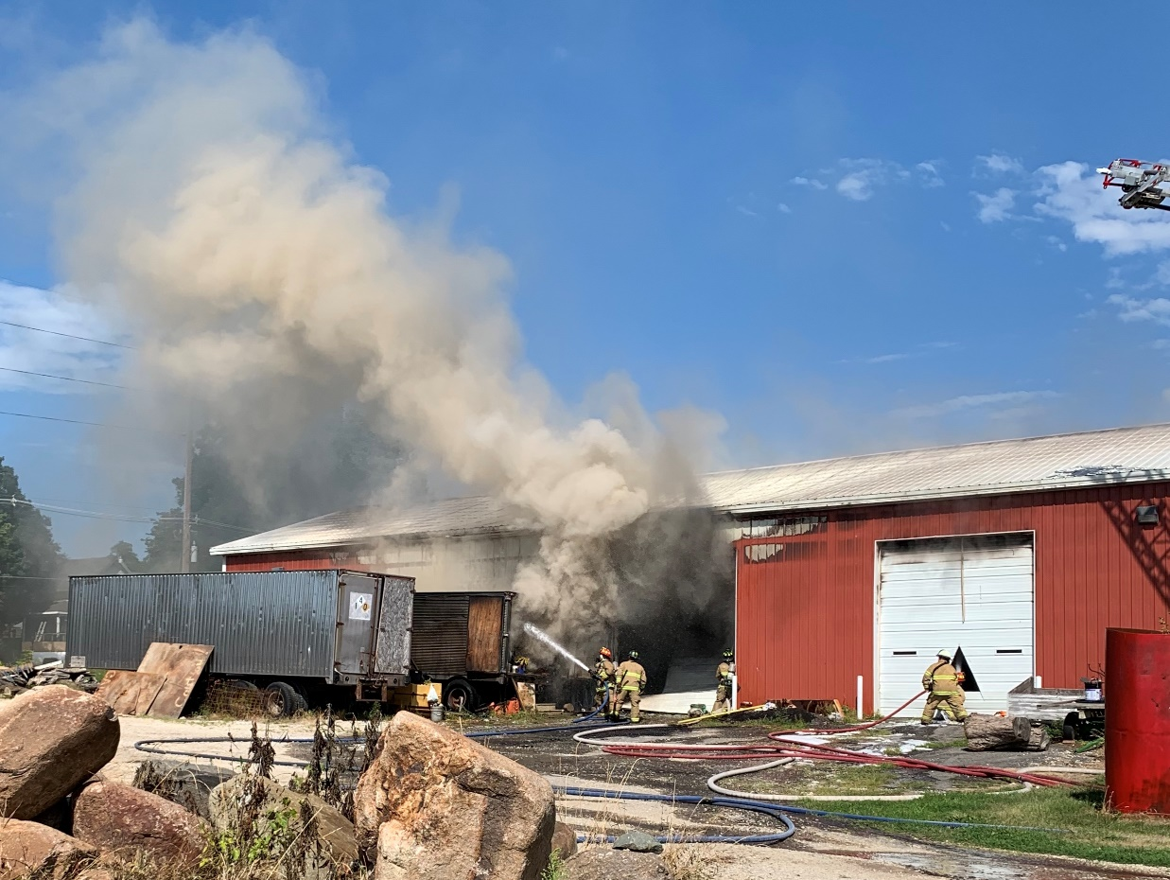
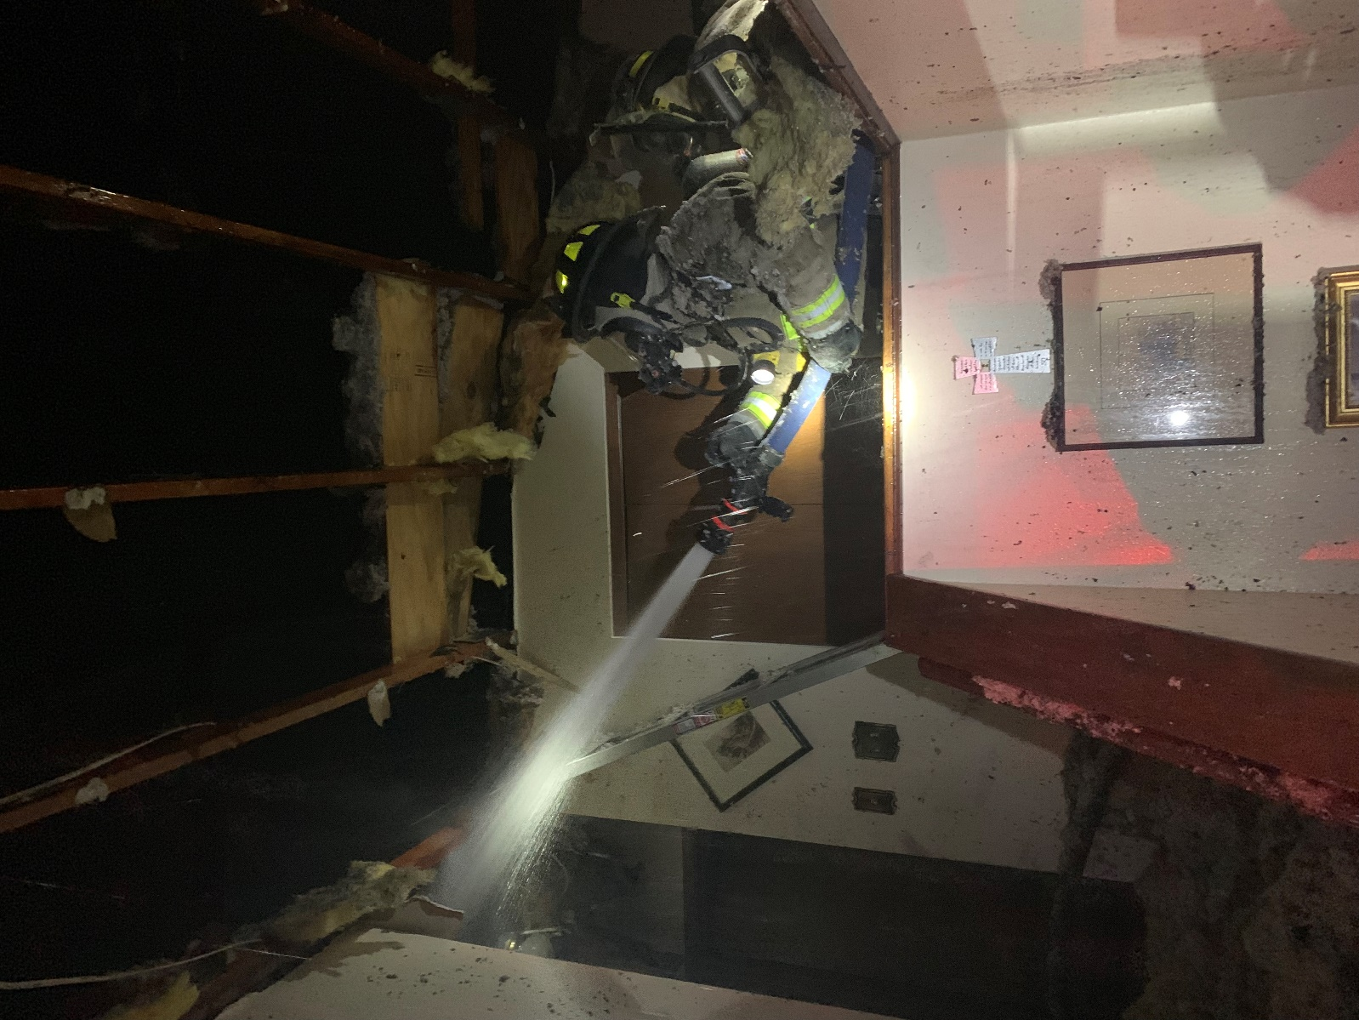

Fire Loss
In 2019, fire loss is valued at $455,570, which is a 49.2% increase from 2018 ($231,350). With a pre-incident value of property involved at $1,341,420, the department saved $885,850 worth of property.

EMS
Marshalltown Fire Department responds with UnityPoint EMS on specific medical calls for service. In some instances, the department arrives on scene prior to the ambulance and begins patient care. Types of calls include cardiac arrest/CPR, difficulty breathing, seizures, diabetics, strokes, and traumatic injuries. Additionally, there are times where the fire department, depending on patient condition, help either render patient care in the ambulance or drive it for the EMS crew to the hospital. In 2019, the department responded to 1,943 medical calls, assisted in patient care16 times and drove the ambulance for the EMS crew 53 times.
Operations
To fully understand our operation and to ensure the best service delivery possible, specific factors related to our service are analyzed. These factors include response time performance, requests by time of day and day of week, overlapping calls, and calls by month. The definition of “response time” depends on the perspective from which one approaches the data. Response time components include call processing and dispatch, turnout time, and drive time to the scene. Call processing time is measured from the time the 9-1-1 call is received to dispatch of the department. Turnout time is measured from dispatch of the department to the time the apparatus leaves the station. Drive time starts when the apparatus leaves the fire station and stops when the apparatus is on location of the incident. Drive time is affected by traffic patterns, time of day, weather patterns, and distance to the incident. For 2019, our department numbers were as follows:
Average Response Time for Emergency Incidents: 5:57
Average Response Time for Non-Emergency Calls: 7:55
Average Response Time for Upgraded Calls: 7:26
Average Response Time for Downgraded Calls: 8:48
Average Turnout Time for Emergency Incidents: 2:07

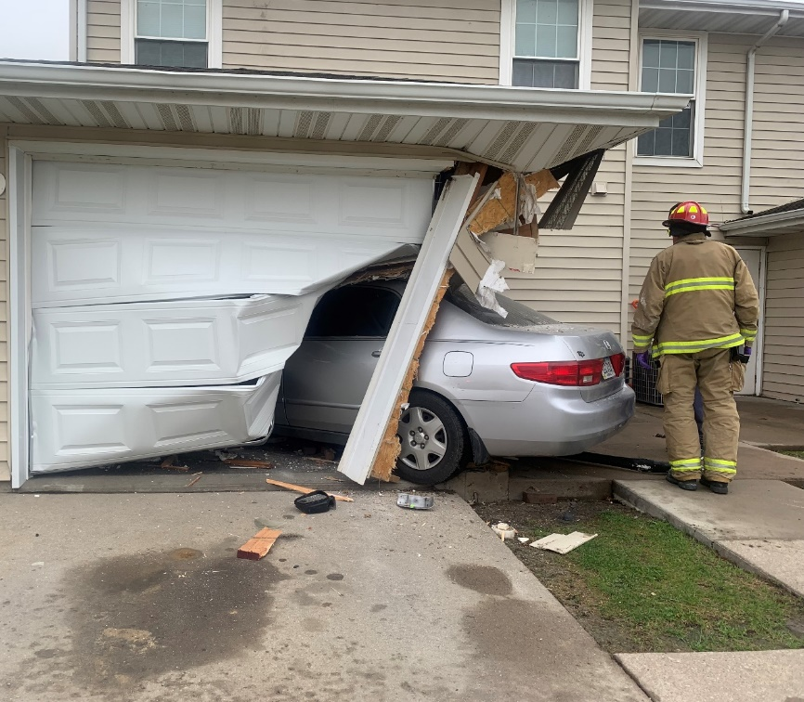

Overlapping Calls:

Overlapping calls are those times when the department has more than one call for service occurring at the same time. This is an important statistic to track as it could result in either delayed or no response. In 2019, we show a 5.1% decrease in overlapping calls (510 vs. 657). After looking at the information, it should be noted that the spike in 2018 was due to tornado response. A visual graph of the overlaps is located below.

Calls by Day of Week:

Calls By Hour of the Day:
As in previous years, the department remains busiest between the hours of 8:00 am and 8:00 pm.

Training and Activity
As an all-hazards department, training is an important part of our annual activity. Training is provided through a combination of in-house instruction, on-line classes, and outside classes and training. In 2019, 12,484 person-hours were spent training in the areas of EMS, fire, hazmat, OHSA, physical fitness, and specialty (confined space, ropes, and water rescue). Additionally, 6,271 person-hours were spent answering calls for service, providing station tours, and maintaining facilities and equipment. Total activity time for 2019 is 18,755 person-hours. Below is a breakdown of the hours.

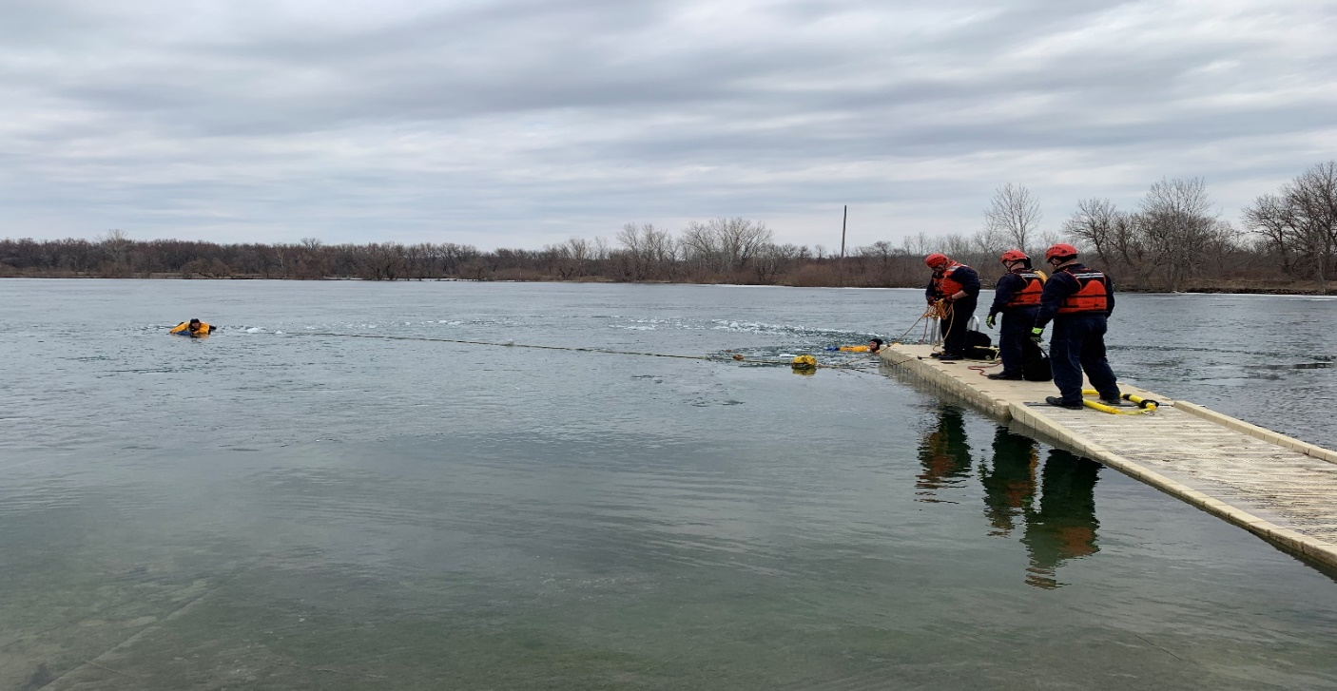
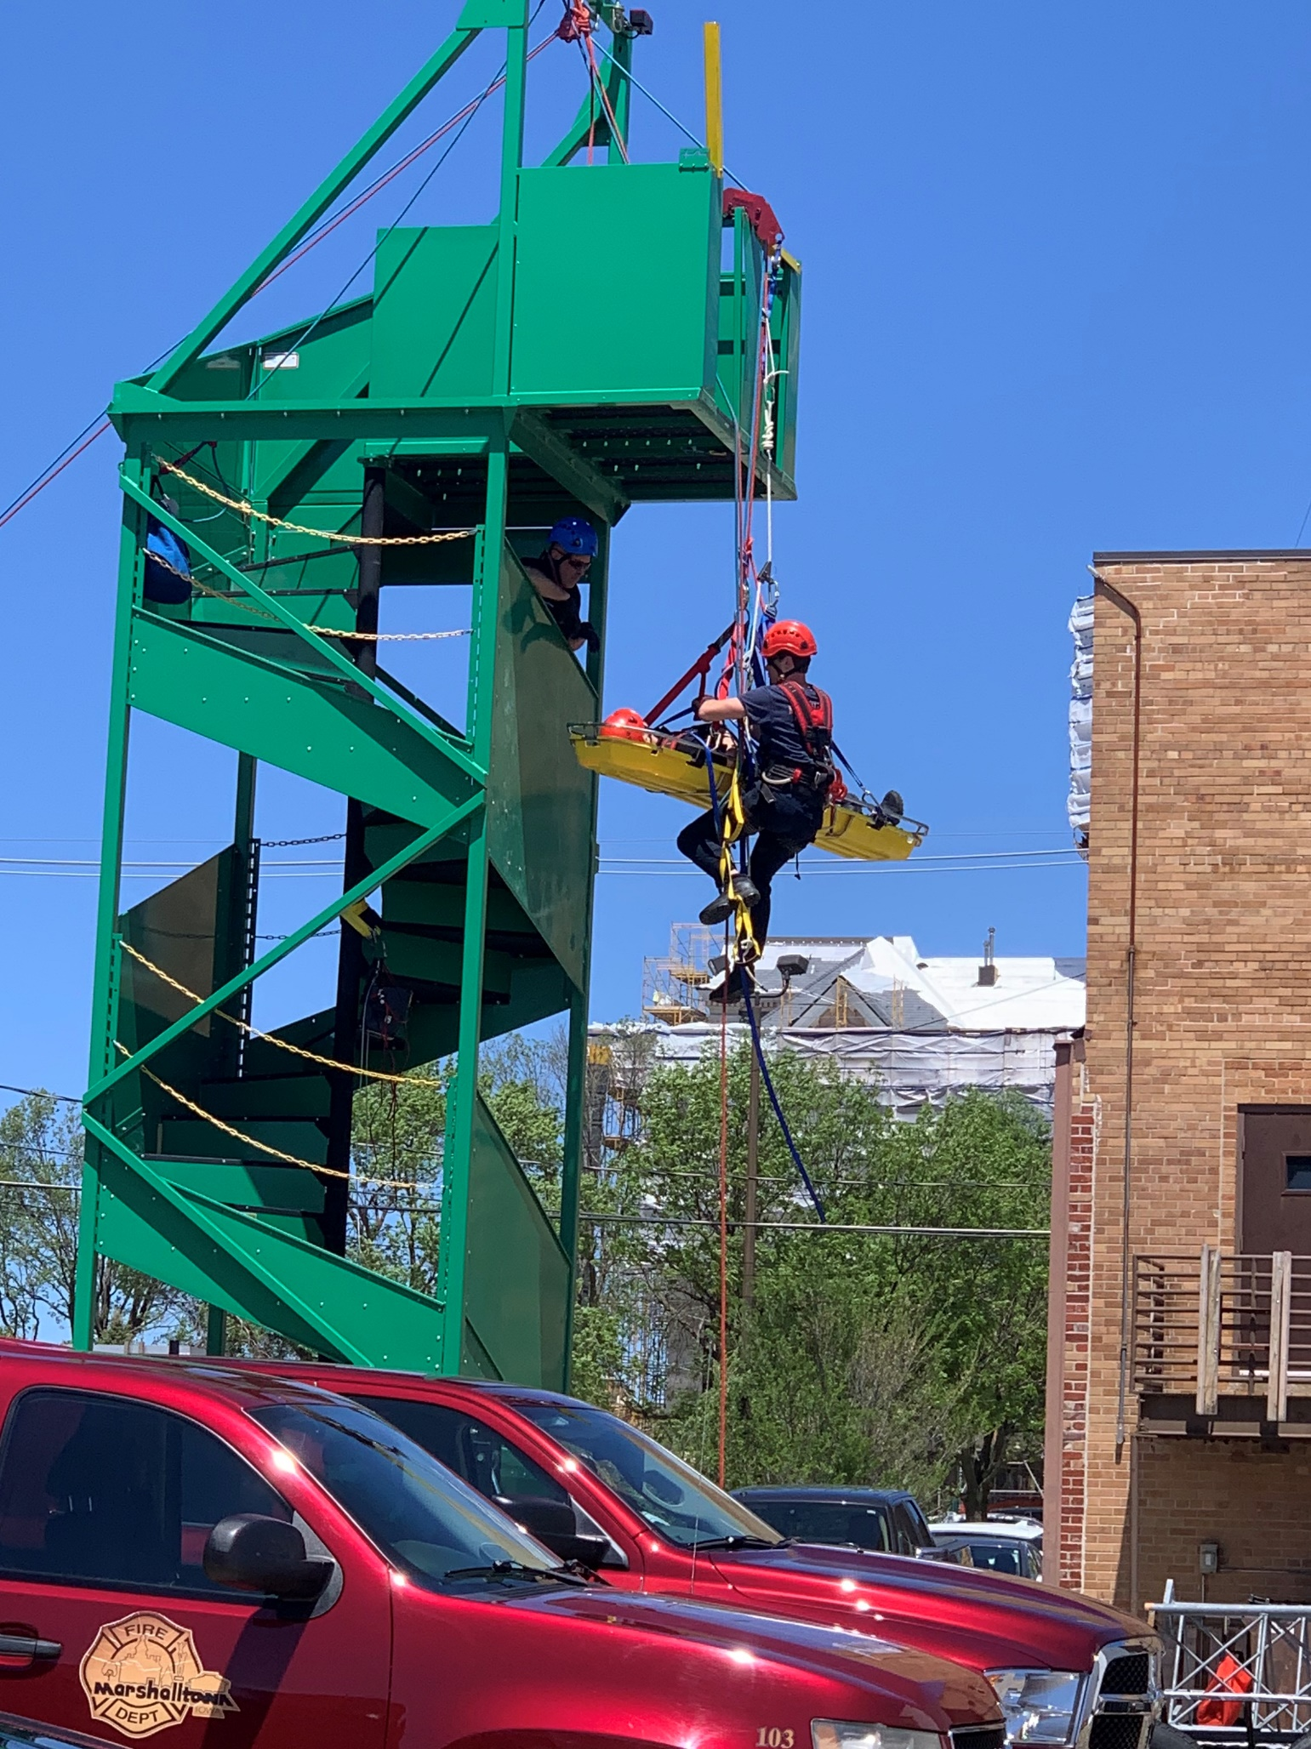
Fire Prevention/Public Education
In 2019, the department participated in 34 public relation/education events. These included reading events at the schools, fire extinguisher training, station tours/open house, block parties, parades, Fire Prevention Week activities, and the Healthy Kids Day. During this time, the fire department was able to provide education and information to 709 kids and 351 adults. Additionally, open house events at the new facility attracted approximately 875 community members. In 2019, the department conducted the Citizens Fire Academy for 14 participants. During this event, participants donned protective equipment and breathing apparatus, pulled fire hoselines and connected to fire hydrants, placed and climbed ladders, performed search and rescue and auto extrication. On last day of the academy, participants extinguished different types of fires at our training facility followed by a cookout at the station.
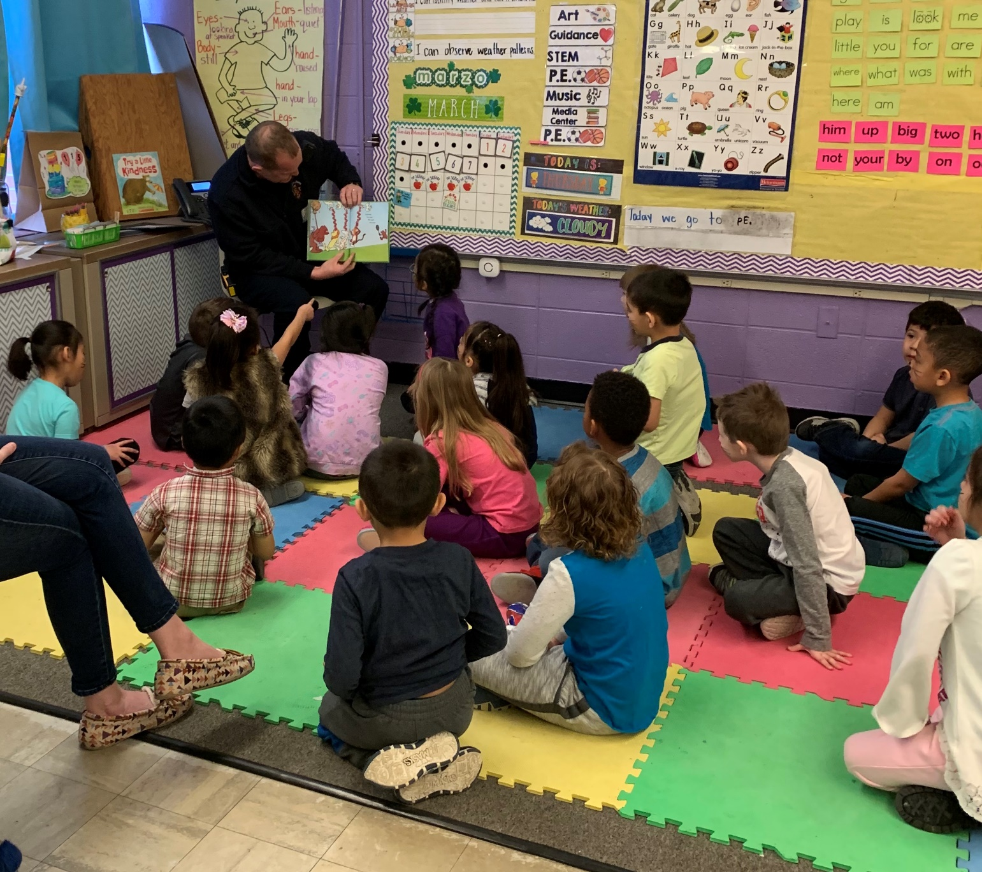

Fire Marshal’s Office
In 2019, the Fire Marshal position was reinstated and inspection activity increased by 14.6% (223 to 261). During inspections, inspectors noted 196 fire code violations. While activity increased, expectations are that 2020 will show significant improvement. Several months of the Fire Marshal’s time in 2019 were spent reviewing, sorting, and moving files and plans to the new facility, as well as reviewing evidence collected during fire investigations. Our affiliation with The Compliance Engine continued in 2019. The Compliance Engine sends notification to property owners who have fire protective systems (sprinklers, hood systems, alarm systems) when service is due, as well as when there are deficiencies in need of correction. In 2019, the Compliance Engine reported 428 system inspections, which included 69 that were non-compliant. In addition to inspections, Fire Investigators conducted 31 fire investigations. During investigations, it was determined that in 15 residential fires no working smoke detector was present.

Retirements, Deaths, New Employees, Promotions, and Anniversaries
For those of us in the fire service, the people we work with become our second families. As such, we celebrate members who have reached milestones in their careers and honor those who are no longer with us. In 2019, Lieutenant Ken Gratopp retired after 29 years of dedicated service to the department and community. 2019 also marks the passing of retired department members Captain Bill Ernst and Firefighter Kevin O’Donnell. In July, Firefighter Nathan White was promoted to the rank of Lieutenant. Lastly, the following individuals celebrated anniversaries with Marshalltown Fire Department:
5 years: Jason Johnston
10 Years: Dan Oswald – Kerri Larsen
15 years: Matt Gorder
20 years: Greg Pepper
30 Years: Scott Doe
35 Years: Tim Hillygus

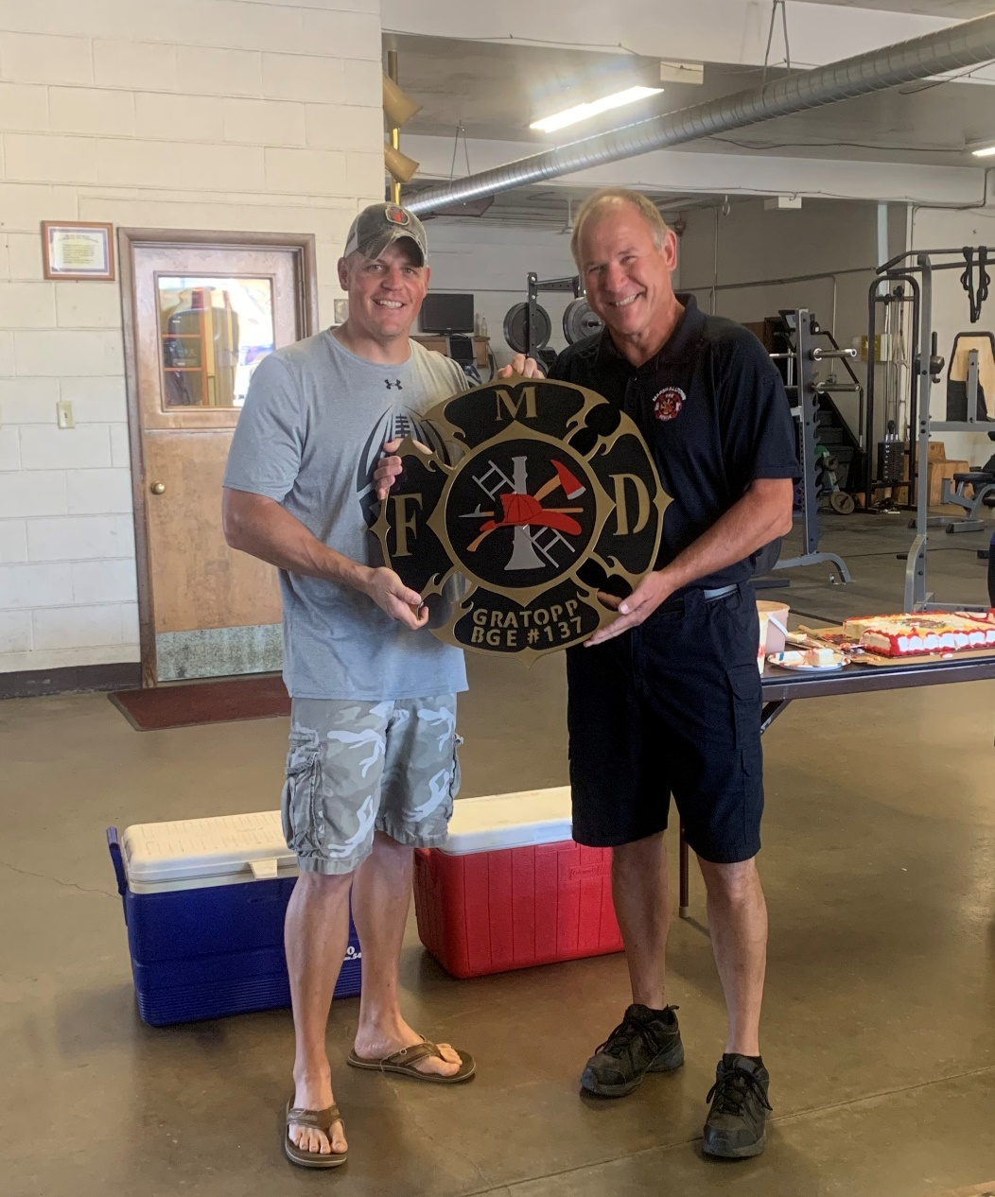
Activity by Shift

A-Shift: 871 calls for service.
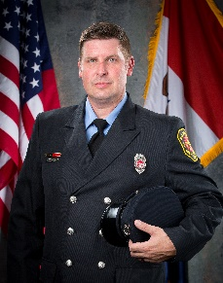
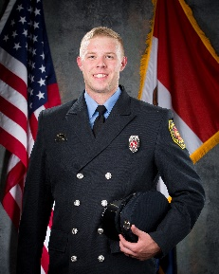
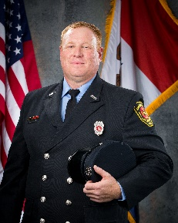
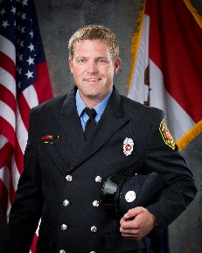
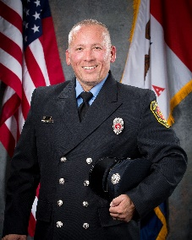
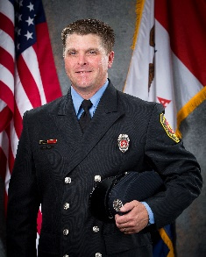
Grant Johnston Schmidt Gorder Wall Burgess

B-Shift: 946 calls for service.
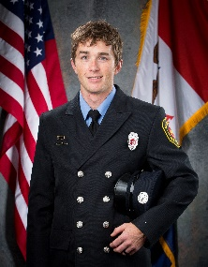
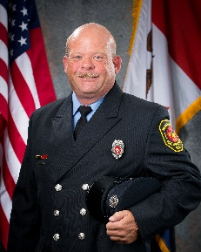
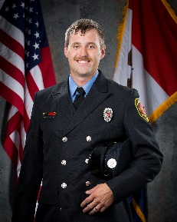
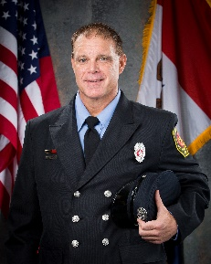
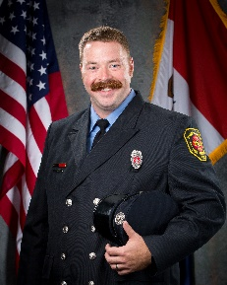
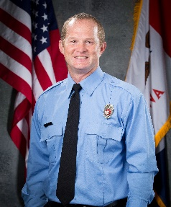
Case Wilson Moore Pepper Oswald Homeyer

C-Shift: 880 calls for service.
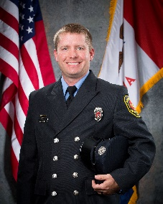
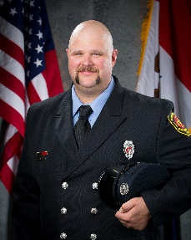
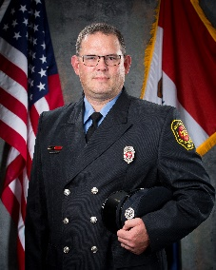
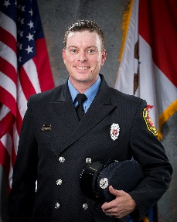
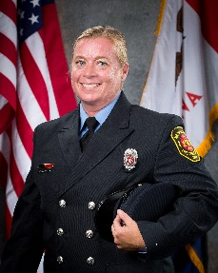
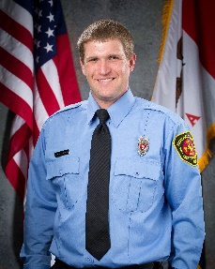
German Raue Larsen Needham Cornwell Weierman

Department Improvements/Updates

The biggest improvement and update in 2019 was the opening of the new Public Safety Building, with the Fire Department beginning operations on August 28th. Improvements include digital signboards showing dispatch information throughout the station, larger training facility that provides the opportunity to host regional and statewide training, improved laundry, decontamination, and showering facilities, and enlarged apparatus bay space that allows all department equipment to be located in one location. Additionally, the Fire Marshal now has the ability to review building/construction plans electronically, which eliminates the need for and storage of paper plans. Moreover, the department has developed a Fire Inspection Notice that contains a list of the most common fire code violations. The notice will be sent to the business owner two months prior to the inspection. Our goal is education and compliance, not to write violations. Lastly, the department is extremely grateful for the opportunity to work in such a beautiful facility and to the community for their support in making it happen.

The Future

In 2020, the Fire Department will continue to look for ways to improve operations, with emphasis on turnout times. Additionally, the department will be working with Marshall County Communications to improve call-processing times.

In the area of training, we will pursue an Officer Development Program for Lieutenants and Captains with Chief Officers either professional designation or re-designation as Chief Fire Officers through the Center for Public Safety Excellence.

Lastly, the department will experience the retirement of two tenured Captains in 2021, which will require a Captain and Lieutenant promotional process to occur in later 2020.

